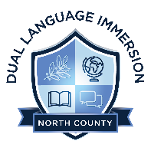
Prospective DLI NC Board Member Application

Biography
First and Last Name:
City/Community of Residence:
Home & Cell Phone Numbers:
Email Address:
Preferred Method of Contact (Email/Home Phone/Cell Phone):
Present Employer and Job Title:

Questions
Please answer each question as fully as possible. Take as much space as you would like in answering questions.

1. Why are you interested in serving on this Board?

2. What skills, knowledge or experience do you have that you believe will contribute to our board?

3. Do you know any of the current board members and how?

4. Do you have any personal or professional constraints on your time that might impact your ability to serve? (Explain time commitment)

5. What are your personal aspirations that could be enhanced by service to the board?

6. Because charter school board members are public officials, are there any situations that you are aware of that may give the impression of a conflict of interest?

7. a) Do you have previous board experience; if so please explain?

b) If so, what made that experience fulfilling for you?

8. Why is the work of the DLI NC School Board important to you?

9. If you have served any organizations in the past, what expectation did you have for management? And what expectation do you have of management of this organization?

10. Is there anything else you’d like us to know about you?

Once completed, please email this form to Vince Vasquez, DLI NC Board Chair, at vvasquez@nu.edu by Friday, April 29th, 2022.

